News Release
InsituTec

For Immediate Release

Measurement Service for Microscale Parts Made Easier

CHARLOTTE, N.C. – A revolutionary microscale measurement service based on patented standing wave technology is available from InsituTec, a Charlotte, NC-based precision metrology firm. The proprietary service provides true 3-D surface profilometry and surface finish measurement capability in one data set.

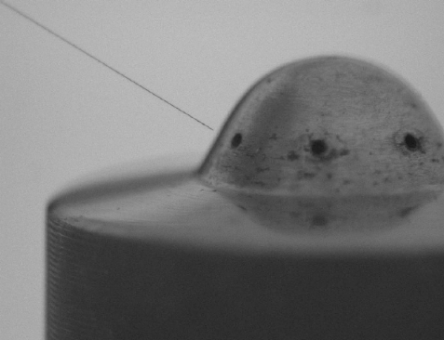
Achieving this level of precision can provide measurements on microfeatures, which represent a rapidly expanding array of products, and is one of the most acute needs in the areas of dimensional metrology. Small features in optical lenses, optical fibers and their connectors, DNA processing chips, drug delivery systems, and a myriad of other applications are increasingly common. These components are delicate and have challenging geometries such as high aspect ratios.
InsituTec’s proprietary new microscale fiber probe measuring diesel injector spray hole

The standing wave is a scanning technology with a high aspect ratio giving the ability to access deep, narrow features. Additionally, this contact based probe has a minimal contact force (estimated to be in the order of 100nN) enabling measurement of delicate parts, with optical quality finishes.

Such fine measurements are needed in varied industries, such as:
• Biomedical, particularly transplant situations such as hip joint or spinal implants;
• Optics;
• Automotive parts and machining;
• Cell phone manufacturers;
• Chip makers;
• Aerospace;
• Advanced plastics.

At InsituTec, work with Beta customers was completed in 2008, validating the measurement capability on parts such as precision threads, injector spray holes, and convex and concave surfaces with steep slopes which are challenging optical metrology tools. These part sizes are typically in millimeters, with features in the micron range. The measurement probe is capable of tens of nanometer repeatability. Microns are the units used to measure very small things, for example the human hair is about 50 to 100 microns thick. A nanometer is 100 times smaller than a micron. A human cell is 10,000 nanometers or 10 microns.

The National Institute of Standards and Technology (NIST) selected InsituTec's proprietary technology to integrate into their Moore M48 measuring machine. Nondestructive measurement of micrometer-sized features on millimeter-sized parts with nanometer resolution is required for NIST’s mission objectives.

InsituTec’s new probe technology for microfeatures will provide NIST the measurement infrastructure needed to characterize microscale devices entering the marketplace as well as the ability to provide microscale calibrated reference standards. Dimensional metrology is important for validation of specified tolerances prior to assembly and understanding advanced manufacturing processes. NIST will continue provided leading edge traceable artifacts to industry and government labs and continue sustaining their competitive edge as a globally recognized standards laboratory.

Company principal Shane Woody says, “The time has come for a new measurement capability allowing both form and surface finish measurements in a single scan and therefore providing a new degree of flexibility and a more complete understanding of the part.” This new measurement service strengthens InsituTec’s position as the provider of a truly unique measurement capability.

###

More information: Please contact the company directly. Dr. Bethany Woody, 704-599-0836, www.insitutec.com

